Imagine a 5-piece cartoon jigsaw puzzle. If you only see 1 puzzle piece, you might get the wrong idea that these are dark storm clouds:    If you only see 2 puzzle pieces, you might get the wrong idea that this is a tobacco pipe with smoke coming out of the bowl:  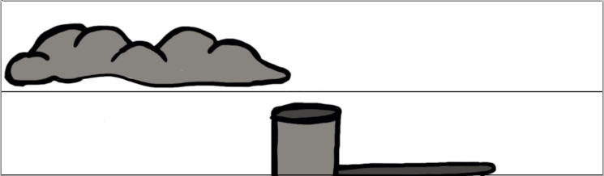  If you only see 3 puzzle pieces, you might get the wrong idea that this is a manufacturing plant with a smokestack:  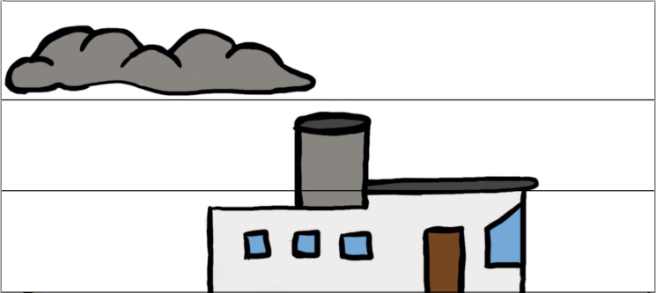  But with all 5 puzzle pieces, it’s clear that the full picture is a steamboat:  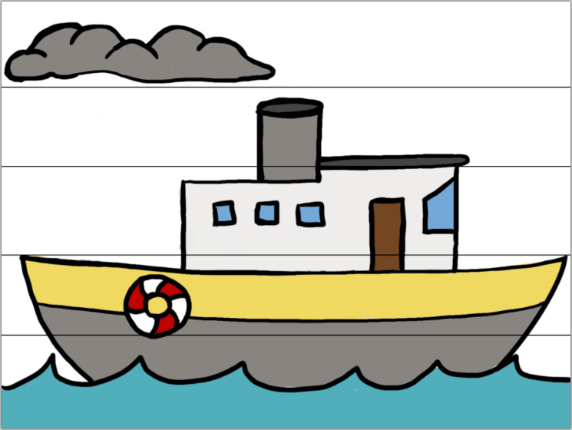  The same thing happens with the Bible. If you only see a few Scripture passages for a topic, you might get the wrong idea and have the wrong view. If you don’t see the full picture for each doctrine in the Bible, you could easily be missing some important information.  If we want to have accurate Christian views in order to honor God, it’s important to try to study all the pieces of information in the Bible for each doctrine. Learn how to do this at:  VividChristianity.com |  |  | Imagine a 5-piece cartoon jigsaw puzzle. If you only see 1 puzzle piece, you might get the wrong idea that these are dark storm clouds:  If you only see 2 puzzle pieces, you might get the wrong idea that this is a tobacco pipe with smoke coming out of the bowl:  If you only see 3 puzzle pieces, you might get the wrong idea that this is a manufacturing plant with a smokestack:  But with all 5 puzzle pieces, it’s clear that the full picture is a steamboat:  The same thing happens with the Bible. If you only see a few Scripture passages for a topic, you might get the wrong idea and have the wrong view. If you don’t see the full picture for each doctrine in the Bible, you could easily be missing some important information.  If we want to have accurate Christian views in order to honor God, it’s important to try to study all the pieces of information in the Bible for each doctrine. Learn how to do this at:  VividChristianity.com

